Chapter 3, Problem 56.

Determine v₁ and v₂ in the circuit of Fig. 3.101.

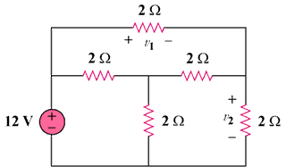

Figure 3.101
For Prob. 3.56.

